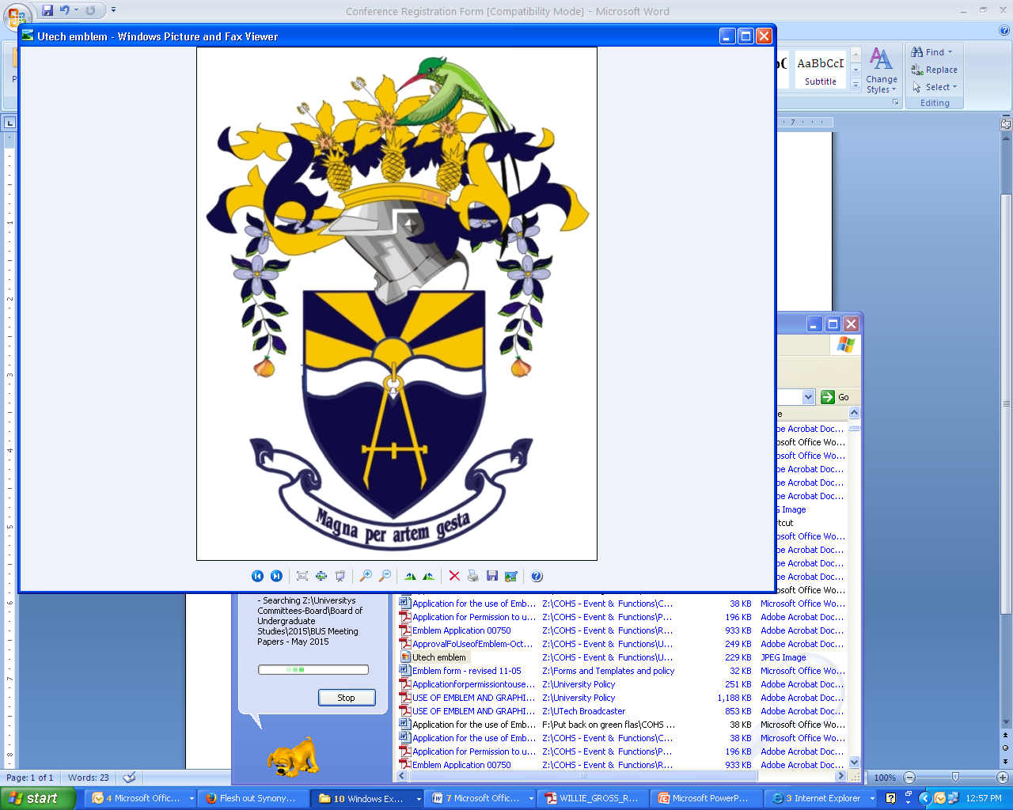
UNIVERSITY OF TECHNOLOGY, JAMAICA
College of Health Sciences
2016 Health Professional Conference
October 22-23, 2016
Kingston, Jamaica

“Nurturing our Children for Life”

REGISTRATION FORM
PERSONAL INFORMATION
Title: [ ] Professor [ ] Dr. [ ] Mr. [ ]Mrs. [ ] Miss [ ] Ms. Other

Degree(s) [ ] PhD [ ] DM [ ] Pharm.D [ ] M.Sc. [ ] MBBS [ ] RN [ ] Bachelor Degree
[ ] Other

Full Name:____________________________________________________________________________

Organization/Affiliation:________________________________________________________________

Mailing Address_______________________________________________________________________

_____________________________________________________________________________________
Country:_________________________________ Telephone: ( )_______________________________
Fax: ( )__________________________Email:______________________________________________
REGISTRATION DETAILS
REGISTRATION FEES
Please check appropriate registration fee: Before/on Oct. 10 After Oct. 10/Onsite
Full registration (2 days) [ ] JA$6000 [ ] JA$6500
1 day [ ] JA$3500 [ ] JA$4000

2 days 1 day
Students with I.D. [ ]4000 [ ] 2500

** Please indicate date of interest: [ ] Saturday October 22 [ ] Sunday October 23

CME/CE/CPAM Required [ ] Yes [ ] No
PAYMENT METHOD
By Cash or Managers Cheque made payable to: University of Technology, Jamaica

Please check appropriate box: [ ]Cash [ ]Cheque [ ]Credit card [ ] Debit card

REGISTRATION Total JA$ ____________________

Signature: _____________________ Date (dd/mm/yyyy): ____/_____/____

Please complete and return via E-mail to yanique.townsend@utech.edu.jm or Fax to (876) 927-1699

CANCELLATION AND REFUND POLICIES FOR REGISTRATION (non-negotiable): All cancellations must be received in writing by the Conference Secretariat. Requests received by October 14, 2016 will be given a 50% refund. No refunds will be made after October 14, 2016.

